**Creating Web APP:**

Step1:

Downloaded visual studio 2017.

Step2:

Creating web app nodejs project and publishing it to azure.

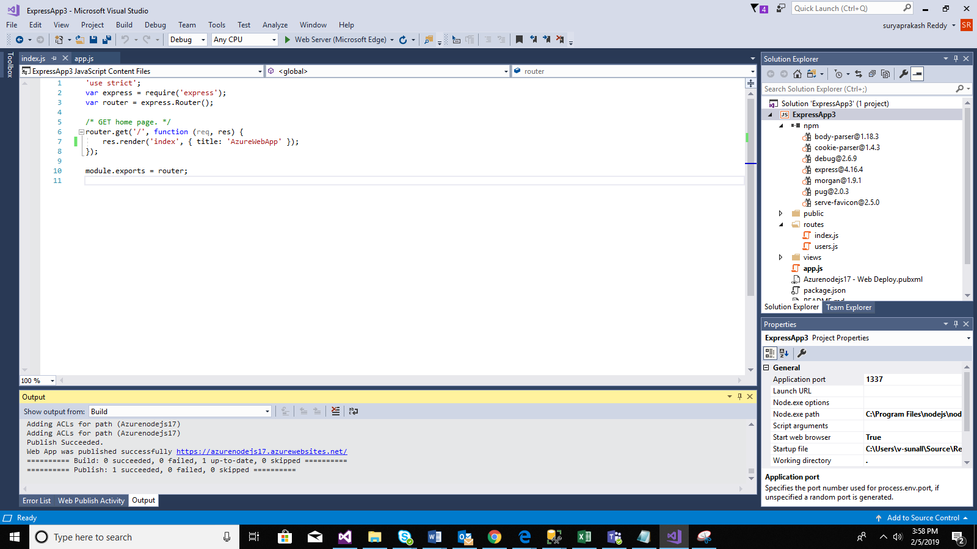

Step3: Creation of Web App.

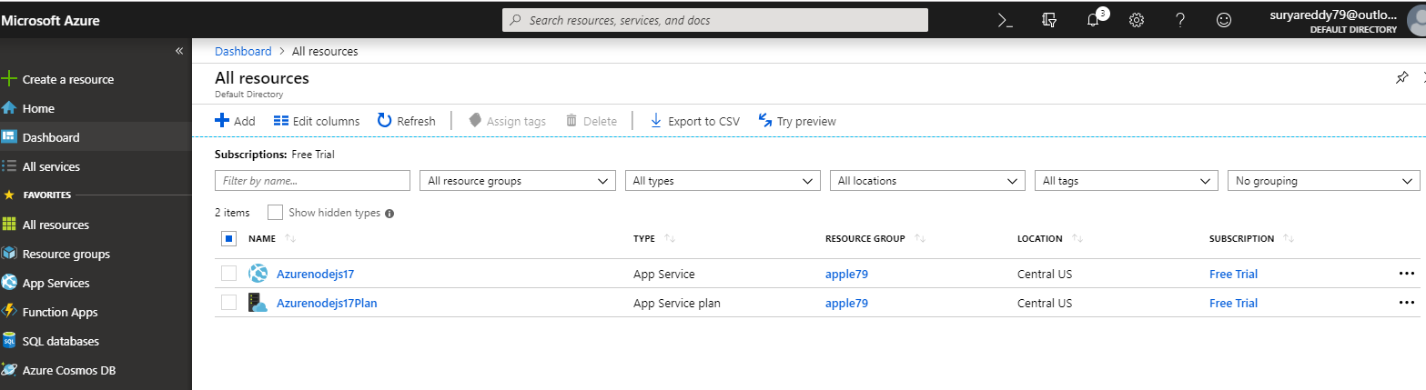

Step4: Finaloutput.

<https://azurenodejs17.azurewebsites.net/>

